**XML**

**Ques 1. Create a XML file containing note as the root element and to, from, subject and body as its child element.**

**Input**

<?xml version ="1.0"?>

<note>

<to>A</to>

<from>B</from>

<subject lang="eng">Web Technology</subject>

<body> Use of XML </body>

</note>

**Output**

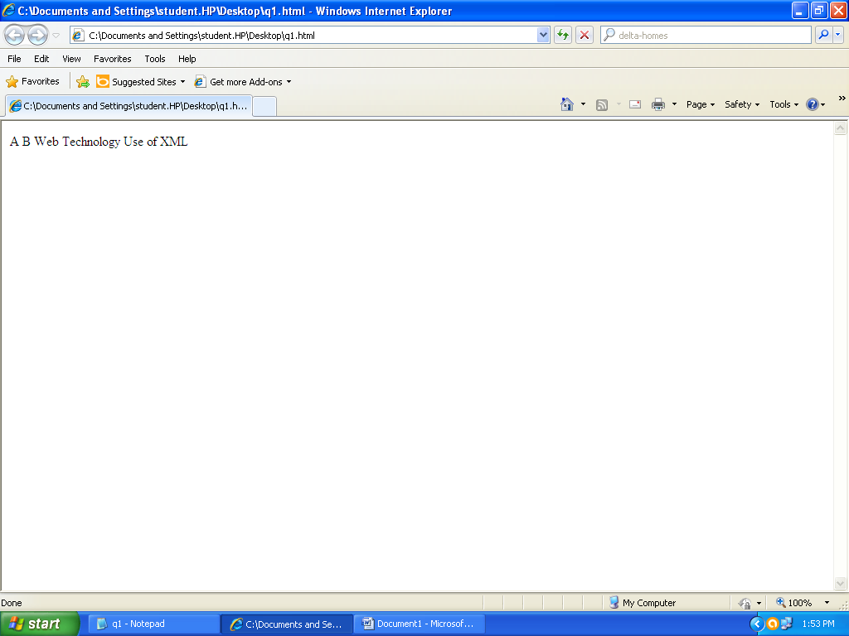

**Ques 2. Create a valid XML document containing the tags mentioned in the 1st question (use internal DTD).**

**Input**

<?xml version="1.0"?>

<!DOCTYPE note[

<!ELEMENT note(to,from,heading,body)>

<!ELEMENT to(#PCDATA)>

<!ELEMENT from(#PCDATA)>

<!ELEMENT heading(#PCDATA)>

<!ELEMENT body(#PCDATA)>

]>

<note>

<to>A</to><br>

<from>B</from><br>

<heading>Remainder</heading><br>

<body>My name is Aman Batra</body>

</note>

**Output**

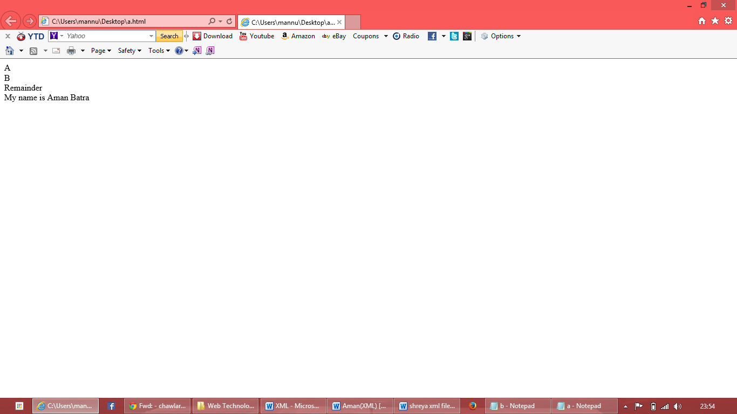**Ques 3. Create a well formed XML file having 5 tags- food_menu , food, name, price and calories .Food_menu is the main parent element that contains food as the child element. Food is the parent element of name, price and calories.**

**Input**

<?xml version ="1.0"?>

<food_menu>

<food> <b> <u>Deserts </u> </b> <br>

<Deserts>

<name>Choclate Fantancy</name>

&nbsp;&nbsp;&nbsp;<price>Rs.100</price>

&nbsp;&nbsp;&nbsp;<calories>150K</calories>

</Deserts>

<Des><br>

<name>Hot Choclate</name>

&nbsp;&nbsp;&nbsp;<price>Rs.50</price>

&nbsp;&nbsp;&nbsp;<calories>100K</calories>

</Des>

</food><br>

<Food1> <b> <u> Italian </u> </b> </br>

<itl>

<name>Pizza</name>

&nbsp;&nbsp;&nbsp;<price>Rs.250</price>

&nbsp;&nbsp;&nbsp;<calories>212K</calories>

</itl>

<mak><br>

<name>Pasta</name>

&nbsp;&nbsp;&nbsp;<price>Rs.100</price>

&nbsp;&nbsp;&nbsp;<calories>110K</calories>

</mak>

</food_menu>

**Output**

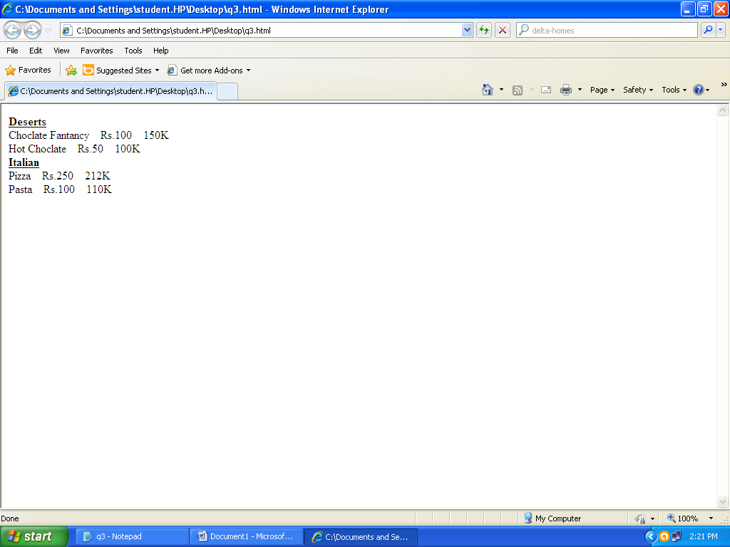

**Ques 4. Create a valid XML document containing employee as the root tag and empname, empno, salary, department as its child tags. Use external DTD to implement it.**

**Input**

<!DOCTYPE employee[

<!ELEMENT employee(emp_no,salary,department)>

<!ELEMENT emp_no(#PCDATA)>

<!ELEMENT salary(#PCDATA)>

<!ELEMENT department(#PCDATA)>

]>

<?xml version="1.0"?>

<!DOCTYPE note SYSTEM "file2.dtd"

<employee>

<emp_no>Emp_no: 40</emp_no><br>

<salary>Salary: 80000</salary><br>

<department>Department: IT</department><br>

<emp_no>Emp_no: 45</emp_no><br>

<salary>Salary: 75000</salary><br>

<department>Department: Manager</department><br>

</employee>

**Output**

